**GPSS**

* GPSS (General Purpose Simulation System) is a high-level simulation language.
* primarily used for modeling discrete event-driven systems.
* It provides various blocks that represent different actions or elements in a simulation model.
* Below is an overview of some key GPSS blocks and their functions:

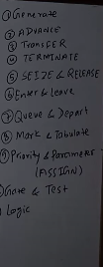

**Generate**  time to come … (action time – transction time a +- B)

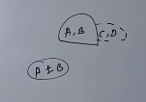

* **Purpose**: Generates entities (transactions) at specified intervals.
* **Usage**: Defines the inter-arrival time of transactions.
* **Example**: GENERATE 5 (Generates one transaction every 5 time units).

**Advance**  how much time work



* **Purpose**: Delays a transaction for a specified amount of time.
* **Usage**: Simulates processing time or delays.
* **Example**: ADVANCE 10 (Delays the transaction for 10 time units).

**Transfer** conditionally divide (probability .. true -S , false -(s-1) )

* **Purpose**: Moves a transaction to a specified block based on conditions.
* **Usage**: Controls the flow of transactions.
* **Example**: TRANSFER 50, Label1, Label2 (50% chance of transferring to Label1, otherwise to Label2).

**Terminate** end of one transction , n means n transctions to do

* **Purpose**: Removes a transaction from the system.
* **Usage**: Ends the lifecycle of a transaction.
* **Example**: TERMINATE 1 (Terminates one transaction).

**Manufacturing shop model 1 single inspector**

A machine tool is turning outparse at a rate of 1 per every 5 minutes. As they are finished, the parse goes to an inspector, who takes 4 (+ or -) 3 minutes to examine each one and rejects about 10 % of the parse. Simulate the system using GPSS model.

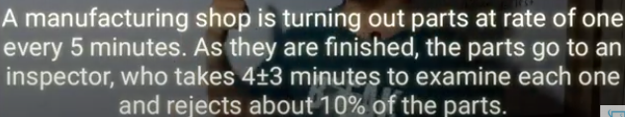

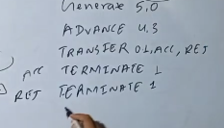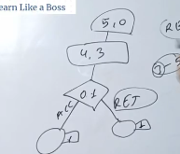

**Facility and Storage**

**Facility** and **Storage** are two important constructs used to represent

resources in a system. They help model resource utilization in scenarios

like servers, machines, or storage spaces.

**Facility - SEIZE and RELEASE**

**Storage - Enter and Leave**



**SEIZE**

* **Purpose: Represents acquiring a resource (like a server).**
* **Usage: Simulates a transaction seizing a facility.**
* **Example: SEIZE Server (Transaction seizes the resource "Server").**

**RELEASE**

* **Purpose: Releases a previously seized resource.**
* **Usage: Simulates completing a process and freeing the resource.**
* **Example: RELEASE Server (Transaction releases the resource "Server").**

**Enter and Leave**

**ENTER**

* **Purpose**: Allocates (or "takes") a specified number of units from a storage facility.
* **Usage**: Used when a transaction requires part of a resource's capacity to proceed.

**LEAVE**

* **Purpose**: Releases (or "returns") a specified number of units back to a storage facility.
* **Usage**: Used when a transaction finishes using the allocated units and frees them for other transactions.

**Manufacturing shop model 2(modified) single inspector**

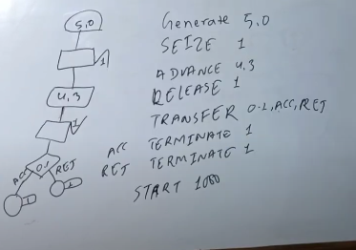

QUEUE and DEPART

**QUEUE**

* **Purpose**: Adds a transaction to a queue and counts the number of transactions in it.
* **Usage**: Models waiting lines or queues in the system.
* **Example**: QUEUE ServerQueue (Adds a transaction to the "ServerQueue").

**DEPART**

* **Purpose**: Removes a transaction from a queue and updates queue statistics.
* **Usage**: Works with the QUEUE block.
* **Example**: DEPART ServerQueue (Removes a transaction from "ServerQueue").

**MARK AN TABULATE**

* **Purpose**: Marks the current time for a transaction, allowing you to later calculate the time spent by the transaction in a specific part of the simulation.
* **Usage**: Stores the simulation clock's current time into a special parameter of the transaction.

TABULATE

* **Purpose**: Records the elapsed time since the last **MARK** for the transaction and adds it to a table (report) for statistical analysis.
* **Usage**: Used to gather data on time intervals for performance evaluation.

**Transfer Special**

**Manufacturing shop model 2(modified) multiple inspector**

**Consider that a machine tool in a manufacturing shop is turning out parts at the rate of one every 5 minutes. As they are finished, the parts go to an inspector, who takes 4±3 minutes to examine each one and rejects 10% of the parts. Now, develop a block diagram and write the code for simulating the above problem using GPSS, and also explain the function of each block used in the block diagram in detail.**

